A 4

Step 1: Capture packets from specific interface.

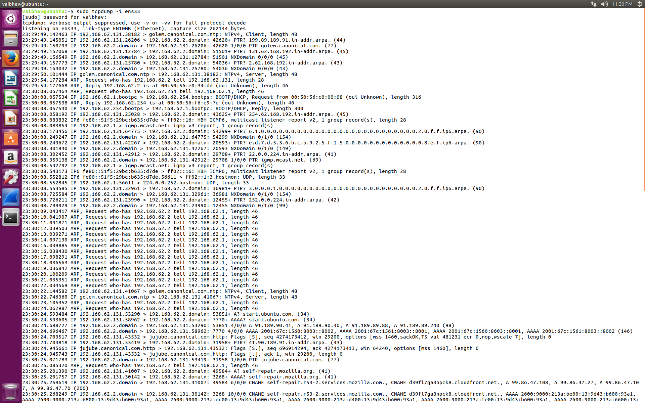

Step 2: Capture only N no of packets.

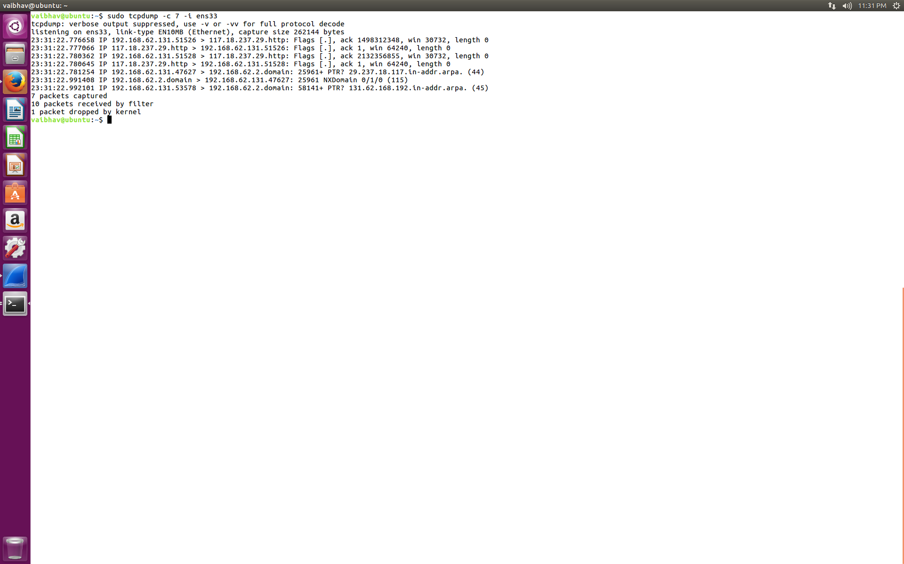

Step 3: Print captured packets in ASCII.

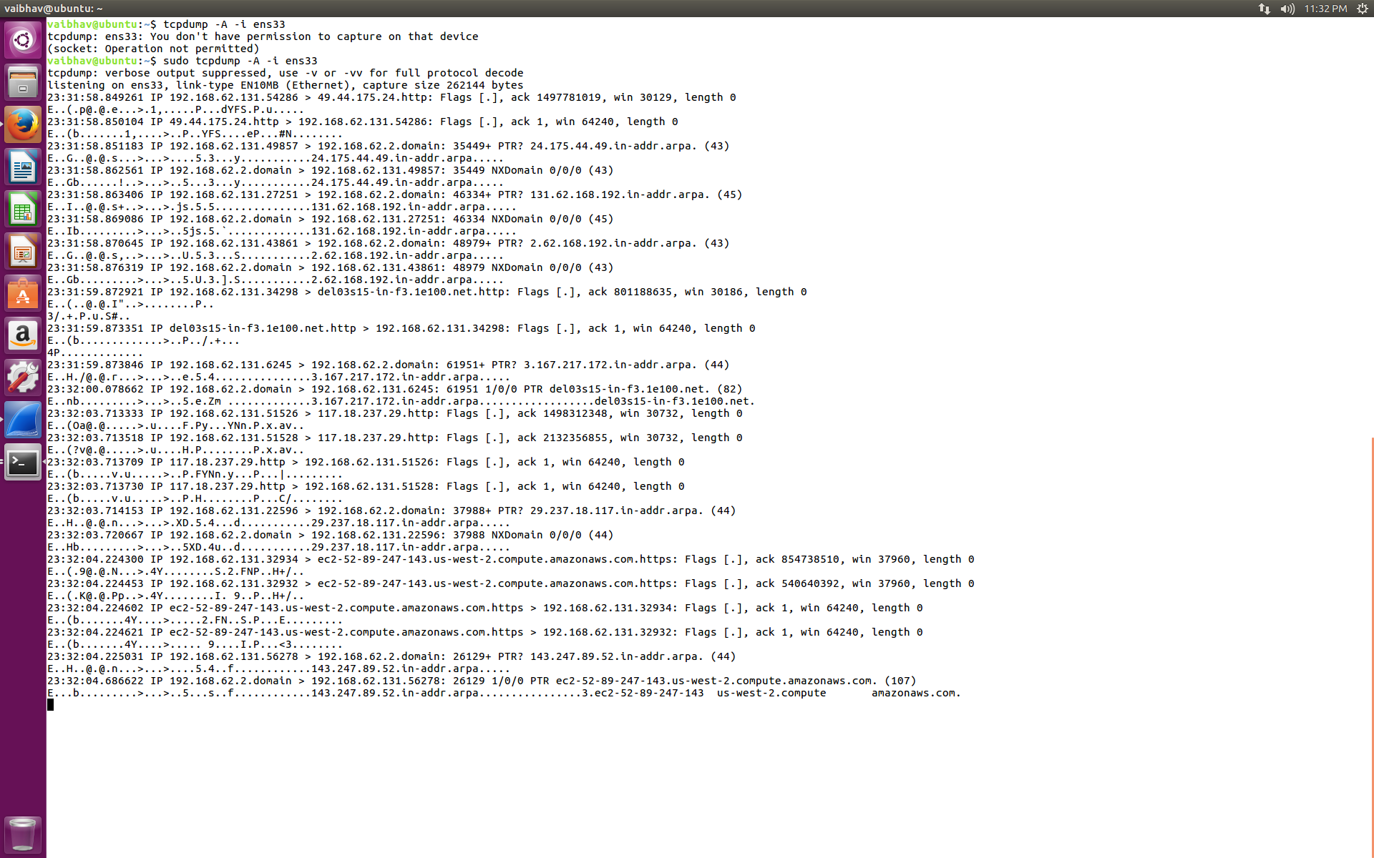

Step 4: Display available interfaces.

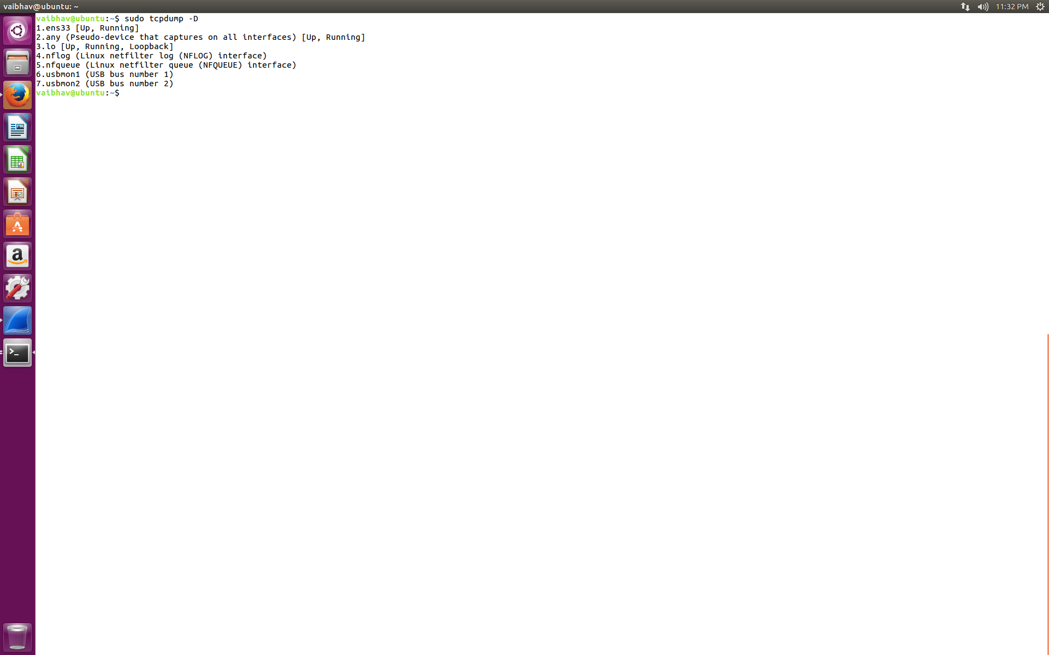

Step 5: Display captured packets in HEX and ASCII.

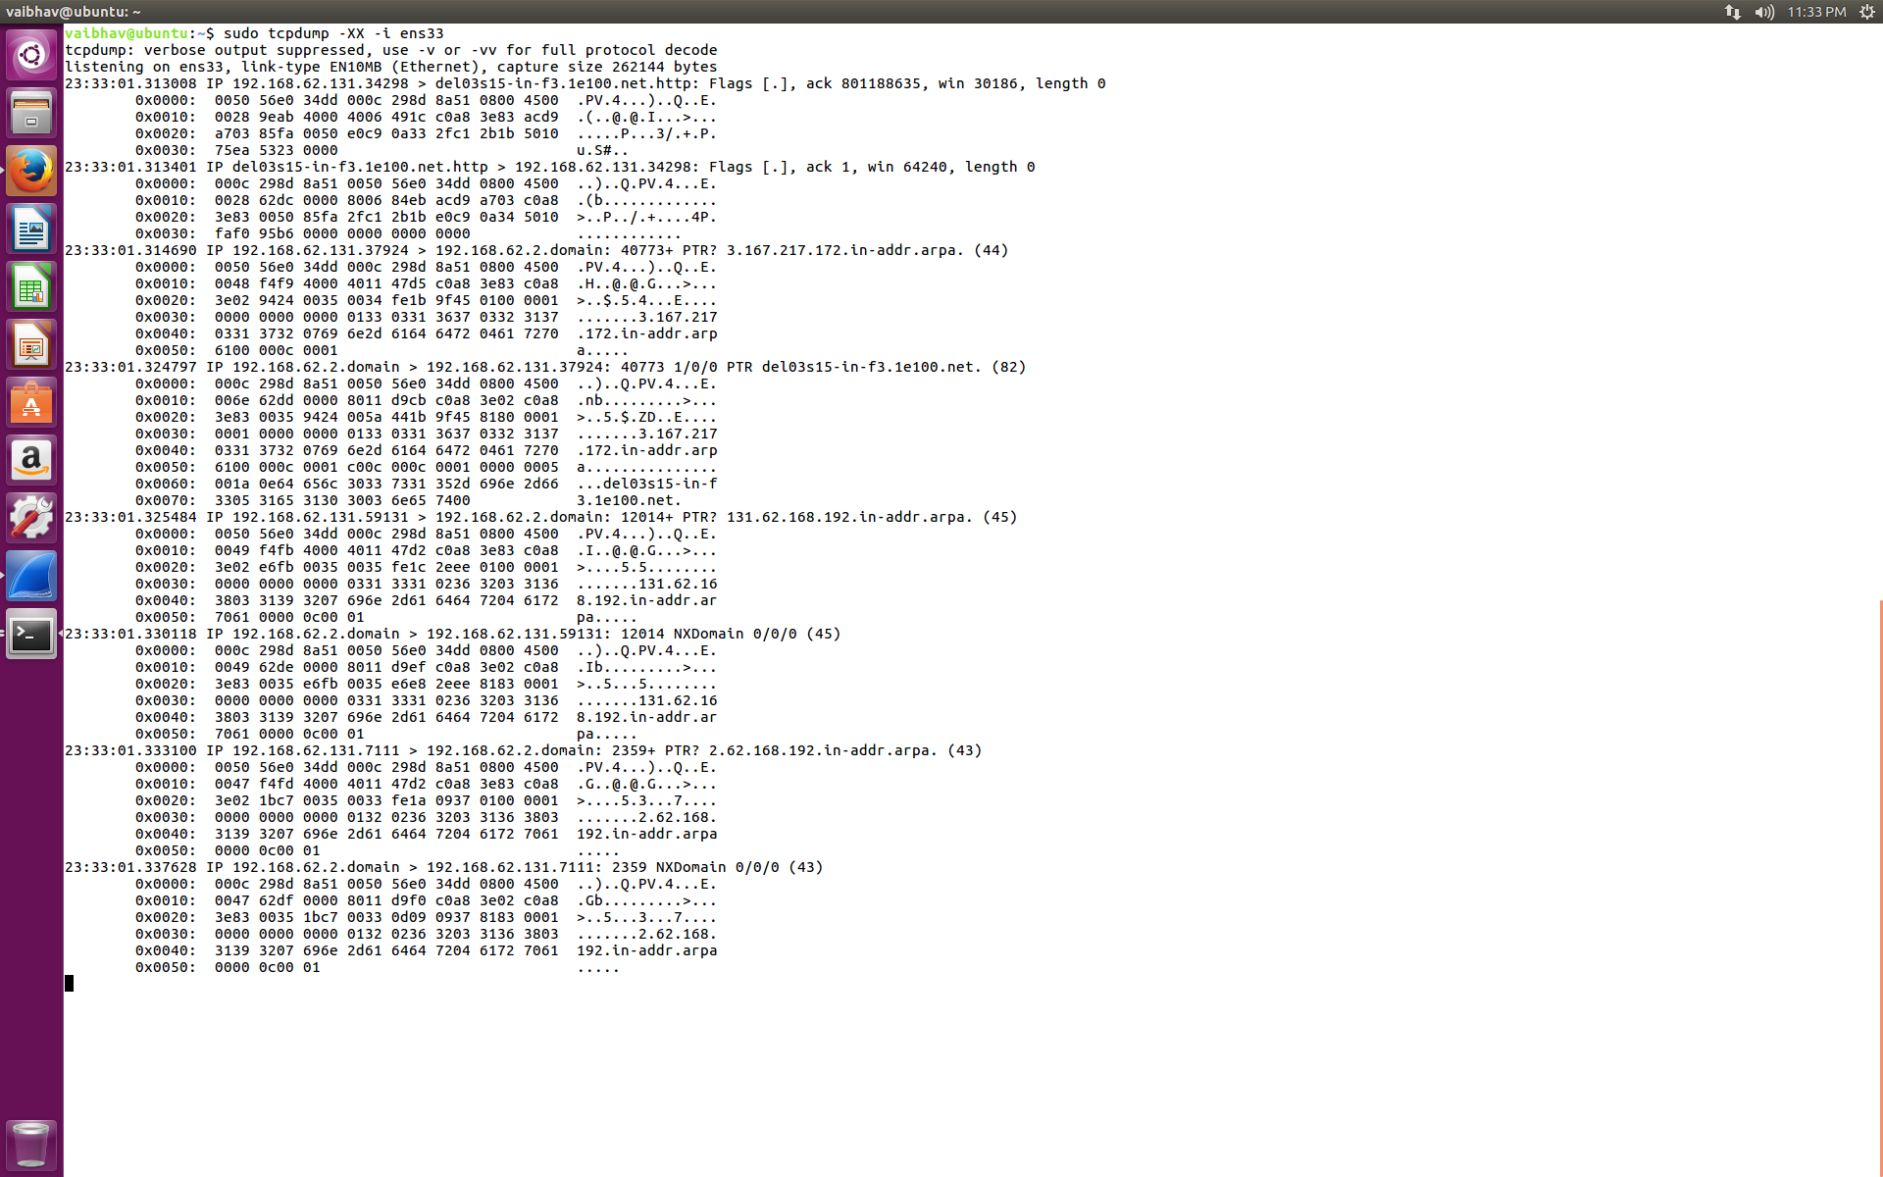

Step 6: Capture and save packets in a file (PCAP).

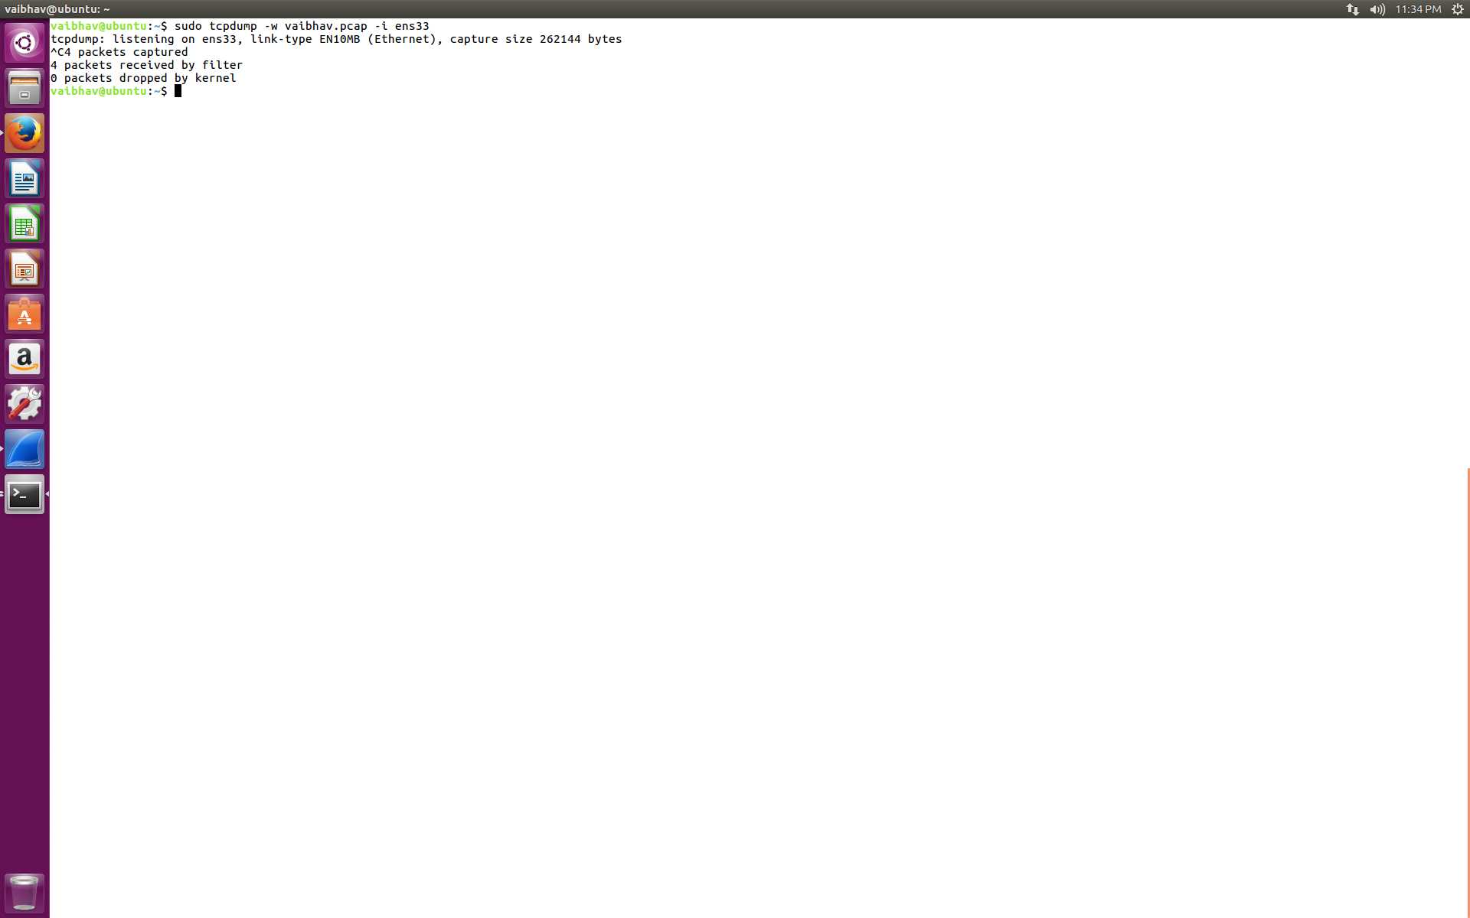

Step 7: Read captured packets file (PCAP).

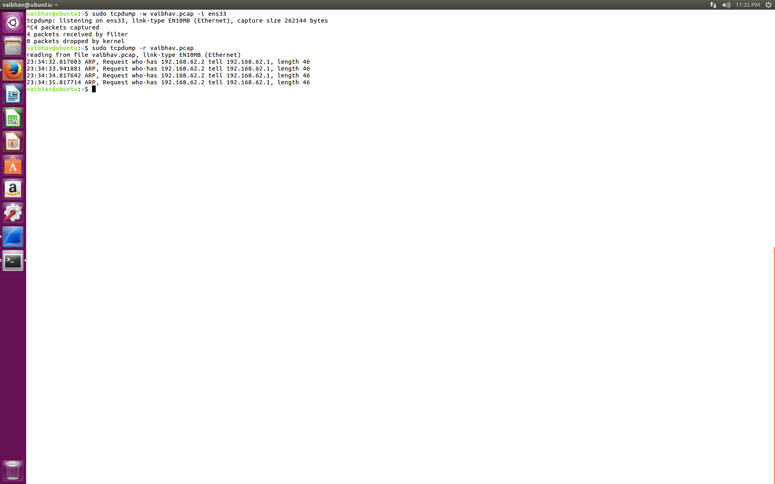

Step 8: Capture IP address packets.

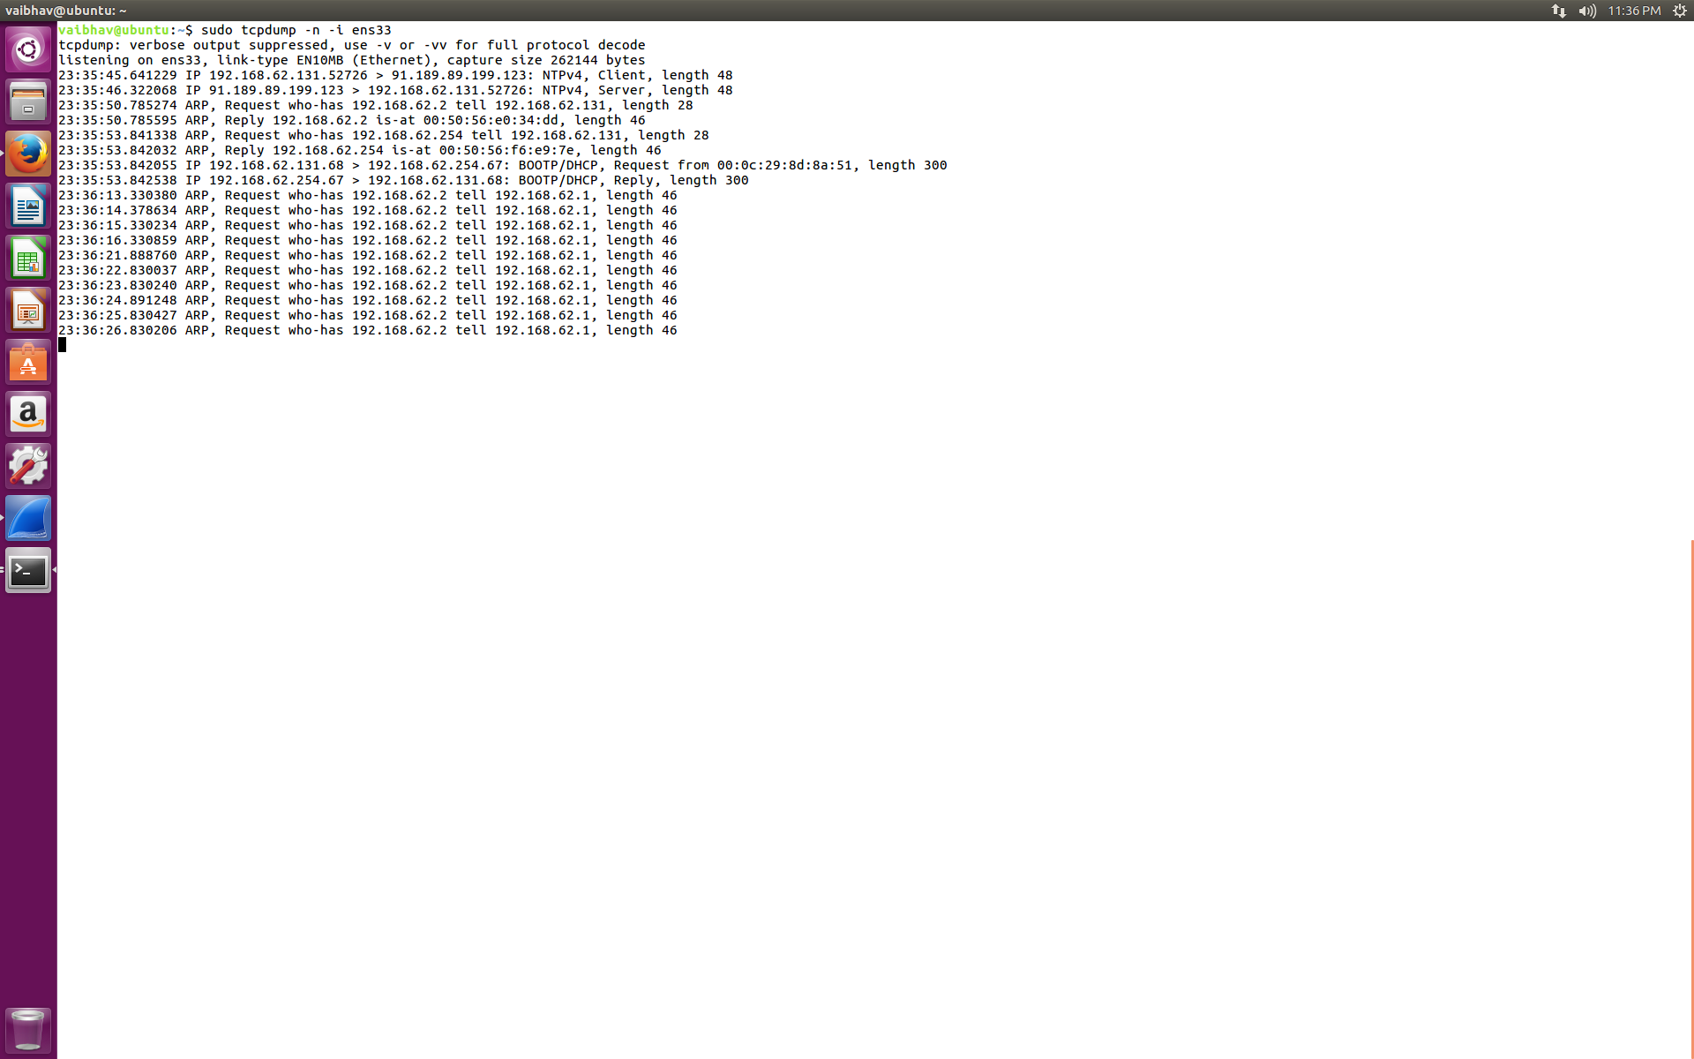

Step 9: Capture only TCP packets.

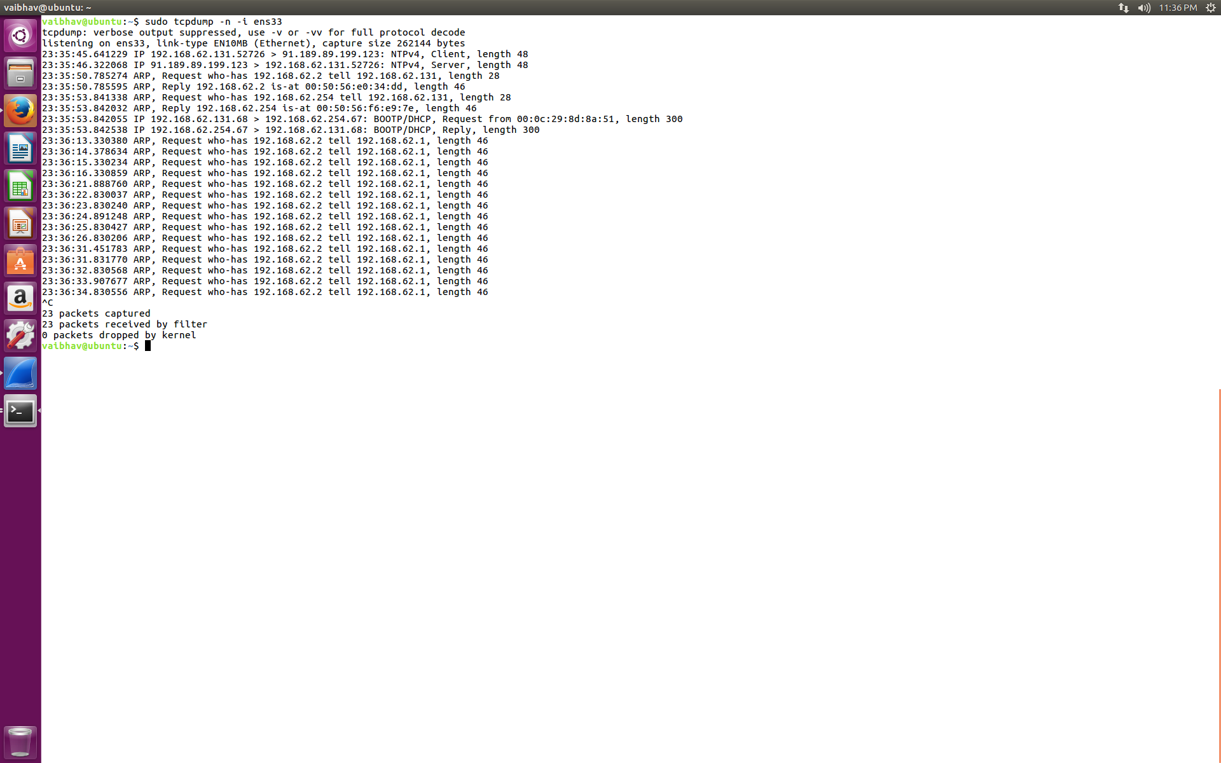

Step 10: Capture packets from specific port.

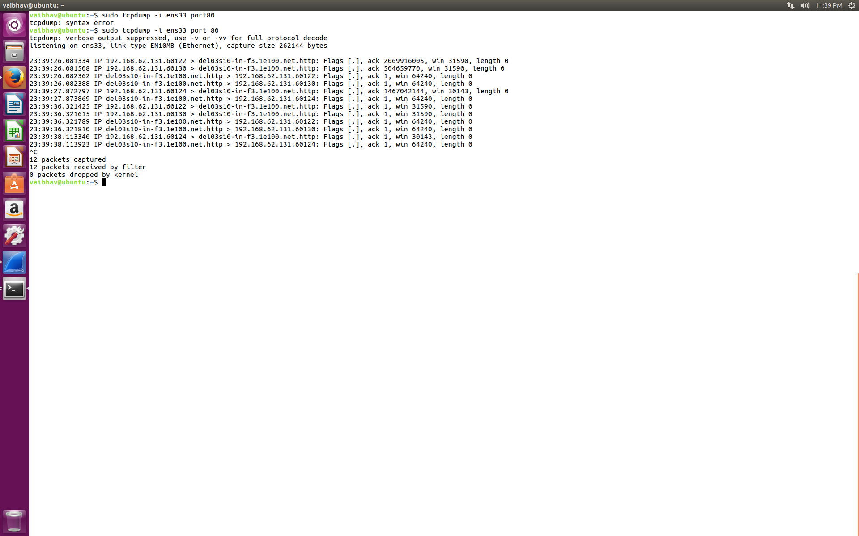

Step 11: Capture packets from Source IP.

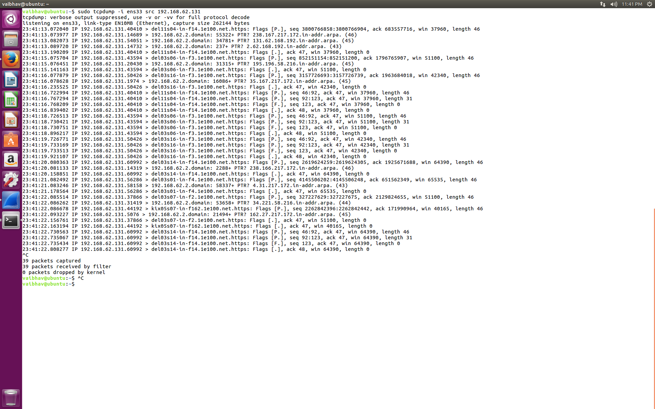

Step 12: Capture packets from destination IP.

